Multi-purpose
INVENTORY HANDHELD
USER’S MANUAL

VERSION V1.02U_2023_04_19_YX

CONTENTS
CHAPTER I BRIEFING 2
1.1 Package List 2
1.2 Safety Cautions 2
1.3 Battery Charging 2
1.4 Accessories 3
CHAPER II FUNCTIONS & OPERATIONS 4
2.1 Overview 4
2.1.1 bootup 5
2.1.2 shutdown 5
2.2 Concise flowchart 5
2.3 Main Functions 5
2.3.1 Collect 5
2.3.2 Inventory 7
2.3.3 Search 10
2.3.4 Settings 11
2.3.5 Program update 12

CHAPTER I BRIEFING

Package List
Inventory Handheld 1
Type-C USB cable 1

1.2 Safety Cautions
Please read the following concise rules. Violation of these rules may cause danger or infringement of the law.
Boot in safety: Don’t switch on the handheld when wireless device is forbidden or is to cause interference and danger.
Interference: all wireless devices may be subject to radio interference which may affect their performance.
Fare use: the handheld can be only used in the purpose described in this manual.
Maintenance: only technically qualified person can disassemble the handheld.
Accessories and battery: use only approved accessories and battery. Don’t connect to inconsistent products.
Water-proof: the handheld is not water-proof, please keep it dry.
Data backup: please make a backup for the data saved in the handheld.
Connection: If in need of connecting to other devices, please obtain necessary safety instructions from their manual or manufacturer. Never connect to an inconsistent device.

1.3 Battery Charging
1.3.1 battery icon：a battery icon displays on top right of the screen to show the battery power. As the battery level going too low to maintain any operation, the Handheld shuts down automatically.
1.3.2 battery charging：the Handheld has a built-in rechargeable polymer lithium battery. For the first 3 times, please make sure the battery is charged over 12 successive hours and it is fully discharged before recharging. The optimal charging time is 6 hours daily. When charging, the indicator light in the upper left corner of the Handheld is green, and it turns off when fully charged.
CAUTIONS：
(1) Only chargers with a voltage of 5V can be used. Using computer USB port instead may cause insufficient charging;
(2) Battery may self-discharge. Please charge up the battery before use if the battery stands idle for a long period;
(3) If a fully charged battery’s life goes short greatly, please replace the battery with a new one;
(4) Do not impact，shock or throw the battery violently, or it may cause leakage, damage or even explosion.

1.4 Accessories
1.4.1 Type-C USB cable
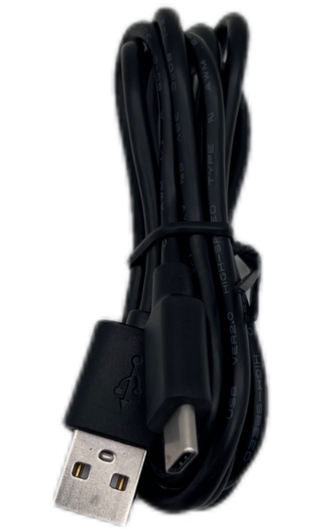

CHAPER II FUNCTIONS & OPERATIONS

2.1 Overview
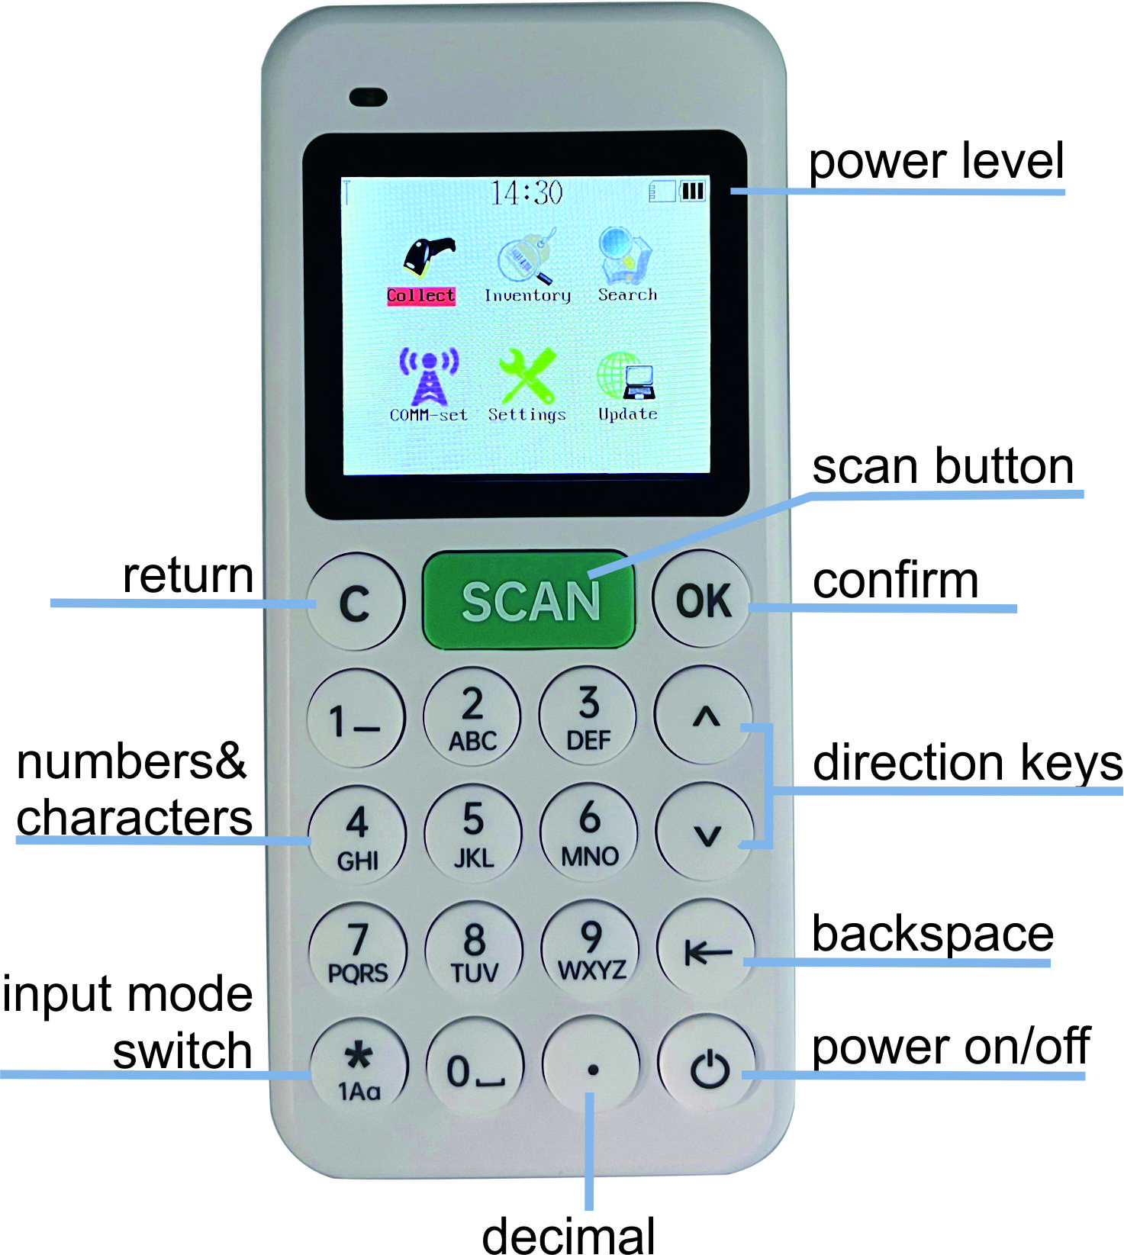
 power on/off
 confirm operations
 return to the previous menu or cancel the operation
 delete the current input information(valid only in the input state). If the quantity field is blank, one press of the backspace key will output a negative sign.
 move among menu options. During inventory scanning, press the down-arrow key to switch between manual and automatic mode.
Manual mode：input quantity manually after barcode scanning.
Automatic mode：the quantity is automatically saved as 1 after barcode scanning.
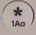 switch among number / capital letter / small letter (valid only in manual input states)
A When creating a new warehouse, press the * key to switch between numbers, uppercase and lowercase letters.
B When entering a barcode, press the * key to switch between numbers, uppercase and lowercase letters.
C In character mode press the key 0 once to input a space, and twice to input a "!".
D In character mode press the key 1 once to input a“-”, and twice to input a “.”.
 input the decimal point in a number.

2.1.1 bootup
Press and hold the power button for 2 seconds till the Handheld turns on.

2.1.2 shutdown
Press and hold the power button for 2 seconds till the Handheld turns off.

2.2 Concise flowchart
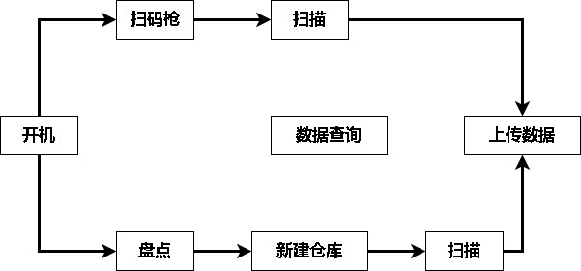
inventory

new warehouse

scan
collect
bootup
search
upload
scan

2.3 Main Functions

2.3.1 Collect
Collect
1.scan
2.upload
3.browse
4.prefix
5.suffix

Collect
1.30410018

saved!

- In the main menu, select “Collect” and press OK to enter the sub-menu.
- select“scan”and press OK to enter the operation page.
- Press the SCAN key to read the barcode.（note:only barcode data is shown on the “Collect” page.）
upload：export files from the USB drive to the computer.
unsent：records not sent to the computer.
sent：records already sent to the computer.
all：sent & unsent records.
upload
Analyse completed
redord：2
amount：2.00

2 to start USB

upload
Analyse completed
redord：2
amount：2.00

stay：0
sent：2
Now copy files from PC

Press key 2 to start and wait for the prompt to complete. Then connect the cable to the computer. An USB flash drive icon will be displayed on the computer. Click to open the OUTPUT WXQIANG folder, and then open the folder named after the date, whiere you can find the BILL0001.TXT file containing the barcode data.
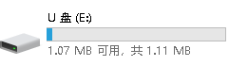
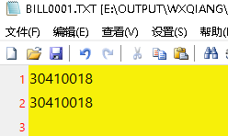
browse：browse the scanned barcode. Press key * may delete a record (uploaded data cannot be deleted).
prefix：set the prefix character of the barcode. Maximum of 6 prefixes can be set.
suffix：set the suffix character of the barcode. Maximum of 6 suffixes can be set.

Note: Characters that can be set as prefix and suffix are: space, tab, carriage return, comma, semicolon and ~. The default setting for prefix is no character, and the suffix is a carriage return. Press the up or down arrow key to move to the desired option, press OK to confirm, and then press again the up or down arrow key to switch and select. Press OK for final confirmation.

2.3.2 Inventory
Warehouse
1.New
2.Select
3.Delete

New Warehouse
Please enter：

New Warehouse
Please enter：
123

1) Select "Inventory" and press OK to enter.
2) New Warehouse: create a warehouse before scanning. Press key * to switch between input methods.
3) Select Warehouse: select a previously created warehouse or delete a warehouse or record.
4) Delete Warehouse: Delete all created warehouses and records.

Inventory
1.scan
2.browse
3.advanced
4.upload-set
5.upload

W.H.：123
STO Inventory M

code:

QTY:

record：0 total：0

STO Inventory M

code:30410018

QTY:1.00

record：1 total：1.00

Example:
- create a warehouse named as “123” . It will automatically enter the inventory menu page.
- Select “Scan” and press OK to enter the operation page. By default, only barcodes and quantity will be displayed.
- press the SCAN key to scan the barcode, input quantity, and finally press OK to save.
browse
1.30410018,1.0

record：1 1/1 P *delete

Advanced
1.Repeat
2.Intercept
3.Default QTY

Repeat
Neglect：
Do not remind repetition
Warn：
Remain repetition

Browse: Browse the scanned data. Press the * key to delete (uploaded data cannot be deleted).
Advanced settings:
-Repeat: Neglect (no warning if a same barcode is scanned); Warn (give a warning if a same barcode is scanned and put a ban on it).
-Intercept: capture a certain part of a barcode. Once the interception digits ahead and interception length are set, the barcode scanned or input will be shown only the captured parts.
Intercept
Digits ahead：
0
Length：
0
Press ‘OK’ to intercept the specified portion from the code.

Intercept
Digits ahead：
2
Length：
3
Press ‘OK’ to intercept the specified portion from the code.

STO Inventory M

code:410

QTY:

record：0 total：0

Example：
For barcode 30410018, the interception digits ahead is set to be 2 and the length 3. It means to intercept the barcode from the 3th digit to the 5th digit. The result is 410.
Default QTY：Set the default value for quantity under automatic mode.
Upload Setting
seperator： ,
terminator：CR
set upload fields

Fields Setting
Bill： 0 Price：0
Barcode：1 W.H.： 3
Lot： 0 Time： 0
QTY： 2 ID： 0

Pls.define export order.
0 means not to be export.
Upload Settings: define the separator and/or terminator of the transmission data (none, space, tab, CR, comma and semicolon available) and specify fields to be uploaded (bill#, barcode, lot#, quantity, price, warehouse, time, handheld ID).
Use the down or up arrow key to move to the desired option, press OK to confirm, and then press the number keys to set the upload order (namely 1 is the first column, 2 is the second column, and so on). Press OK for final confirmation. 0 means not to be exported.
Example:
Upload the scanned data with the separator of “," (comma) and the terminator of "CR" (carriage return) , and in the order of barcode, quantity, and warehouse. Then, the content in the TXT text generated by the USB flash drive should be as the figure below:
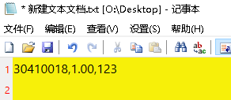
i.e. Enable fields of bill#, barcode, lot#, and quantity.
Fields Setting
Bill： 1 Price：0
Barcode：2 W.H.： 3
Lot： 3 Time： 0
QTY： 4 ID： 0

Pls.define export order.
0 means not to be export.
STO Inventory M

Bill:
Code:
LOT#:

QTY:

Entering bill#...
仓库：123
STO Inventory M

Bill:123
Code: 30410018
LOT#: A001

QTY:1

Entering QTY...
仓库：123

The file exported is as shown below:
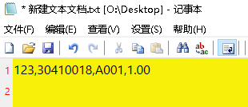
upload：export files from the USB drive to the computer.
unsent：records not sent to the computer.
sent：records already sent to the computer.
all：sent & unsent records.
upload
Analyze completed
record：2
amount：6.00

2 to start USB

upload
Analyze completed
record：2
amount：6.00

stay：0
sent：2
Now copy files from PC
Press key 2 to start and wait for the prompt to complete. Then connect the cable to the computer. An USB flash drive icon will be displayed on the computer. Click to open the OUTPUT WXQIANG folder, and then open the folder named after the date, whiere you can find the BILL0001.TXT file containing the barcode data.
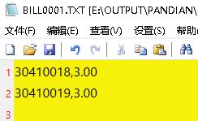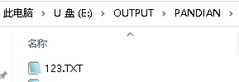
Note: if the field of bill# is enabled, the file generated will be named after the bill number.

2.3.3 Search
You can conduct a query by category (press the backspace key to switch), start date, end date, a bill#, warehouse, and/or barcode. When browsing, you may delete the record by pressing the * key (uploaded data cannot be deleted).
Search
Job type：all
start：2018/01/01
end：2018/11/14
bill：
W.H.：
code：

Search
result：4
qty：5.00

press OK for details
1/4 Browse

code：30410018

QTY：1.00

W.H.：123 *delete

2.3.4 Settings
Time: to set the date, clock, automatic shutdown and standby.
Press the up or down arrow key to highlight the option, and OK key to confirm the selection. Then input the parameters with the number keys, and press OK for final confirmation.
Machine ID: to assign a number/code for each handheld.
Press OK to enter the number.
Clear Memory:
Clear records: clear all scanned data.
restore: clear all scanned data and restore settings.
Factory default: wipe data and initialize parameters.
Other Options:
Rate: set the upload interval of each record (0.1 - 0.8 seconds available).
Repet-set: whether to remind a repeat barcode
Neglect - no warning if a same barcode is scanned
Warn - give a warning if a same barcode is scanned and put a ban on it.
Form type: Detail or summary option is available. When switching, the scanned data will be cleared.
Detail: each scan generates one record, and records are exported in the order of scanning.
Summary: the same barcode with the same warehouse will be aggregated and saved in one record, and exported in the order of the first saved record.
About: hardware version, number of records, memory used and program version.
About
HW Ver.：A
records：4
RAM： |

Firmware Version：
V1.00-2018/11/14

2.3.5 Program update
Screen ID: used to confirm program category to be updated
Version: used to distinguish between program versions.
Device ID: the unique serial number of the handheld
Note: the handheld is no need to get update in general. Please seek for customer service if update is indeed necessary. If you accidentally enter the update interface, just press the power key to shut down and then restart.

